Ackerman Park Improvements Update:
8/2/19 to 9/6/19

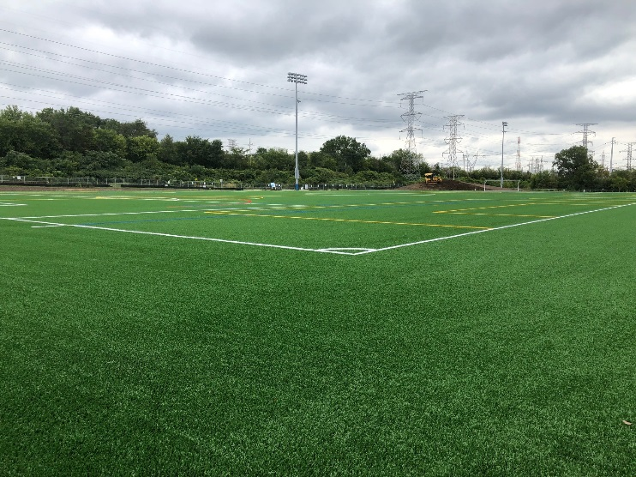
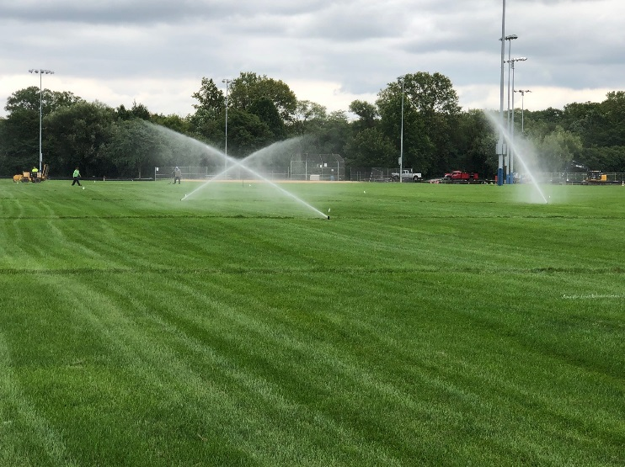
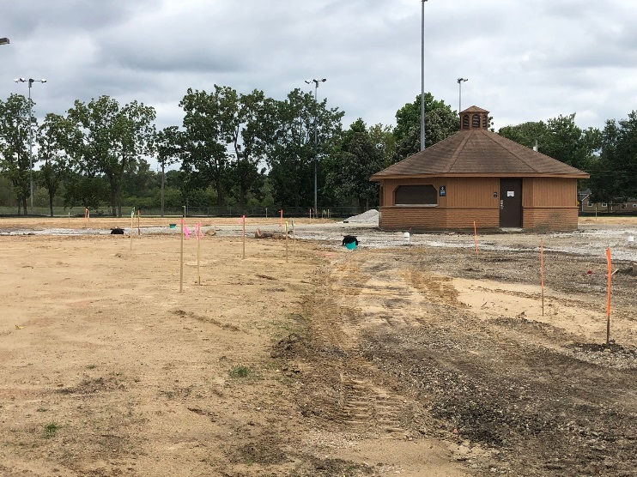
Work Completed:

- Installation of concrete curb around entire perimeter of turf field
- Synthetic turf installation is complete. The field
will begin to be used the week of September 16 (tentatively)
- Upper trail edge restoration
- Stormwater management improvements within lower Ackerman
- Final grading of area around synthetic turf field
and natural grass soccer fields to the east
- Irrigation lines were extended along with installation of sprinkler heads to the perimeter
of the turf field, new grass fields and middle
area of lower Ackerman
- Athletic light adjustments and preparation to relocate southwest pole
Upcoming Work:
- Installation of Hub softball backstops

- Seed and blanket of exposed soil areas

- Continued site work within lower Hub

- Modifications to enable soccer tournament to
take place the weekend of September 26 – 29

- Installation of lower Ackerman trail

